Code Analysis – Challenge Solution: Wonderland 5
By: Tehila Chananayev

Introduction
This challenge presents an assembly code snippet where the user is prompted to input the name of a file they have created. The program then loads the file's contents into memory and checks whether it contains the correct sequence.
Our goal is to perform reverse engineering on the program’s logic — to understand the verification process it applies and determine the exact input (e.g., a number or string) that passes the check successfully.
It's important to note that the solution must be achieved without any cracking or code modification, and without altering registers or memory. The challenge is solved purely through logical analysis and understanding of the assembly code.

Code Structure

Before executing the main challenge logic, the program prompts the user to input a file name via standard input. It reads the input using fgets, removes the newline character, and opens the specified file in read-only mode using CreateFileA. Then, it reads up to 1024 bytes from the file into a local buffer using the ReadFile API. If the file fails to open or read, the program does not proceed further.
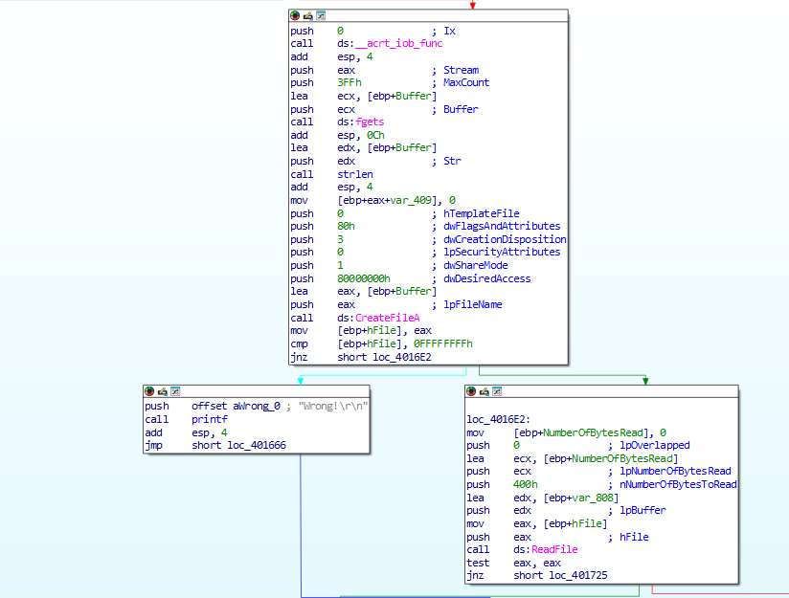

Then, the program reaches the critical and most interesting part — a function I named msteryfunc. This function acts as the core challenge: if it completes successfully and returns EAX = 1 (i.e., TRUE), we win. Otherwise, if it returns EAX = 0 (FALSE), we lose.

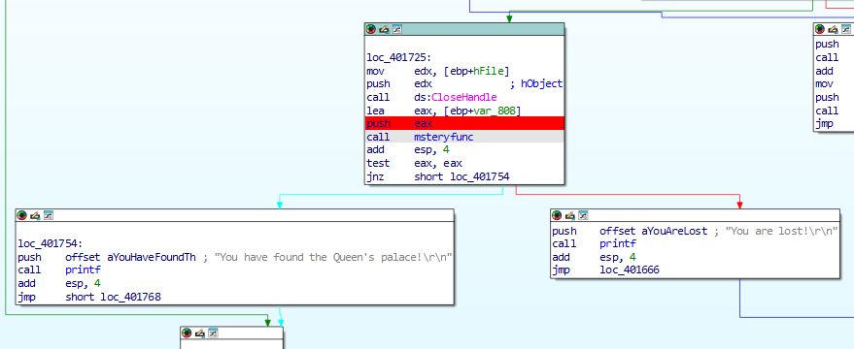

Function msteryfunc
To analyze and understand the behavior of the function msteryfunc and determine the required input that causes it to return TRUE.
The msteryfunc function receives the contents of the file passed to eax and implements path navigation logic via an encoded string (Str) in memory. This string consists of:
'#': Walls (not allowed to be stepped on)
'.': Correct path (allowed)
'O': Starting point
'X': Destination point
Initially, the function uses the strchr function
to find the address of the character 'O' in the string and stores a pointer to it (i).
It then loops over the input string provided in user_input, and based on each character (instruction), it moves the result pointer accordingly.
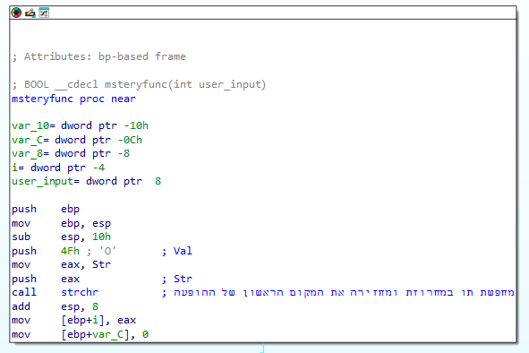

Game Rules
What happens is that there is a switch according to each instruction that appears in the contents of the file passed to the function, it does the following thing
Each input character ('1', '2', '3', '4') represents a directional command:
Input movement character Effect on result pointer
'1' Move result right i++
'2' Move result right (forward) i+16
'3' Move result left i--
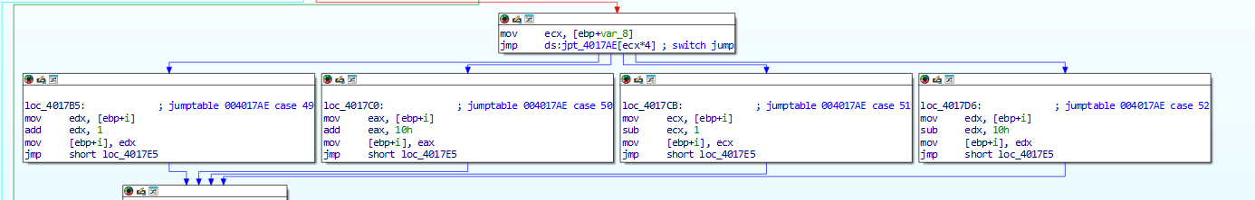
'4' Move result left (backward) i-16

What Does the Function Do?
It simulates a navigation puzzle through a memory-based map (Str), starting at 'O', and following a sequence of moves given as characters in the input.
Each move must land on a '.' (dot). If the moves eventually reach 'X' exactly when the input ends — the function returns TRUE.
If the path hits a wall ('#') or finishes in the wrong place — it returns FALSE.
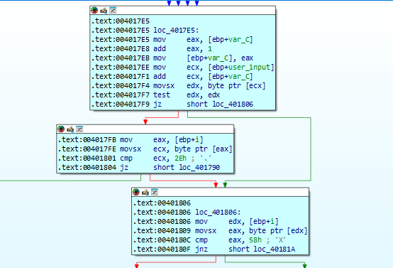

This is essentially the string str where everything is done in a maze and the goal is to reach x according to the rules.
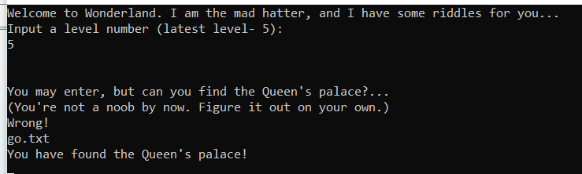
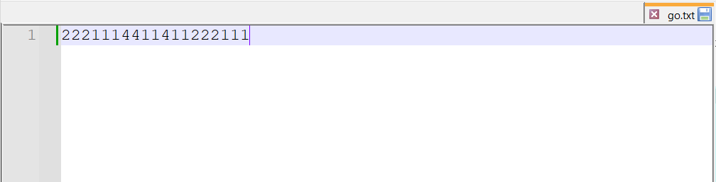
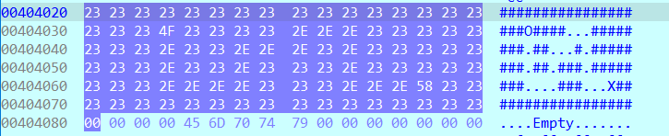
In the file I put the series of commands that leads to success

